Leoni obtains first order from Scania for engine harnesses

Supply in Europe and the Americas – Customer base of European truck manufacturers completed

Nuremberg / Hanover, 24 September 2014 – Leoni won the first order from Scania. The Swedish truck manufacturer awarded the leading European provider of cables and cable systems to the automotive sector and other industries to supply engine harnesses for several engine models. Having Scania as its customer, Leoni now counts all major European truck manufacturers among its commercial vehicles clientele.
Thanks to its high reputation in the field of engine harnesses for commercial vehicles and to its global development and production presence, Leoni managed to obtain the order from Scania to manufacture wiring harnesses for a variety of engine platforms. The contract comprises the multinational supply of high quality products in Europe and Brazil beginning in mid-2015 and will last three years in a first step.
Leoni will produce complex wiring harnesses, which connect all electric and electronic components of the whole truck engine as well as sensors and control units with each other.
(1,140 characters incl. blanks)

About the Leoni Group
Leoni is a global supplier of wires, optical fibers, cables and cable systems as well as related services for the automotive sector and further industries. Leoni develops and produces technically sophisticated products from single-core automotive cables through to complete wiring systems. Leoni’s product range also comprises wires and strands, standardised cables, special cables and cable system assemblies for various industrial markets. The group of companies, which is listed on the German MDAX, employs about 66,000 people in 33 countries and generated consolidated sales of EUR 3.92 billion in 2013.

Imagery
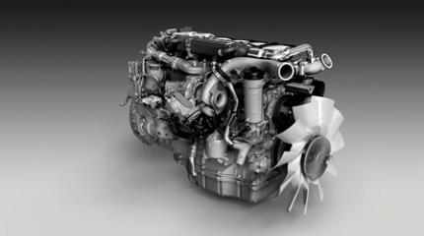
© Photo: Scania 2013

Leoni obtained the order from Scania to manufacture wiring harnesses for a variety of engine platform.

(Image 13061-004; download here from the homepage www.scaniaimagearchive.com)

Contact person for journalists
Sven Schmidt
Corporate Public & Media Relations
LEONI AG
Phone +49 (0)911-2023-467
Fax +49 (0)911-2023-231
E-mail presse@leoni.com

